Advancing BERT: Fine-Tuning Inefficiency using LoRA

1. Introduction
BERT (Bidirectional Encoder Representations from Transformers) is one of the most powerful models used in Natural Language Processing (NLP) tasks such as sentiment analysis, text classification, and question answering. Despite its high performance, BERT suffers from a major limitation: high computational cost during fine-tuning.
Full fine-tuning of BERT requires updating all parameters (~110 million), which leads to increased training time and resource consumption. This makes it inefficient, especially for systems with limited computational power.
In this project, we address this limitation by using LoRA (Low-Rank Adaptation), a parameter-efficient fine-tuning method. The main objective is to reduce the number of trainable parameters and training time while maintaining similar performance.
The task used for evaluation is sentiment analysis on the IMDb dataset.

2. Related Work
BERT, introduced by Google, revolutionized NLP by using bidirectional context understanding. However, its large size makes it computationally expensive to fine-tune.
To overcome this issue, several parameter-efficient techniques have been proposed:
- Adapter Layers: Small neural layers inserted between transformer layers
- LoRA (Low-Rank Adaptation): Introduces low-rank matrices into attention layers
- Layer Freezing: Freezing some layers to reduce computation
LoRA is particularly effective because it reduces the number of trainable parameters significantly while preserving model performance.

3. Methodology
3.1 Dataset
- Dataset Used: IMDb Sentiment Analysis Dataset
- Total Samples: 50,000
- Training Samples: 25,000
- Testing Samples: 25,000
The dataset consists of movie reviews labeled as positive or negative.

3.2 Preprocessing
- Tokenizer Used: bert-base-uncased
- Maximum Sequence Length: 256
- Padding: Applied
- Truncation: Applied
The text data is converted into numerical tokens suitable for BERT input.

3.3 Models Used
Baseline Model: Full Fine-Tuning BERT
- Model: BERT (bert-base-uncased)
- Approach: All parameters are updated during training
- Total Parameters: 109483778
Improved Model: LoRA-based BERT
- Model: BERT with LoRA
- Technique: Low-Rank Adaptation
- Only a subset of parameters is trained
- Total Parameters: 109780228
- Trainable Parameters: 296450

4. Experiments
4.1 Training Setup
- Batch Size: 8
- Number of Epochs: 1
- Learning Rate: 0.1
- Logging every 100 steps
- Evaluation Strategy: per epoch

4.2 Evaluation Metrics
The models are evaluated using:
- Accuracy: Measures correct predictions
- F1 Score: Balances precision and recall

4.3 Hardware Configuration
- Device Used: GPU
- Training Environment: Google Colab

5. Results
Results Table
Model | Accuracy | F1 Score | Training Time (Minute) | Total Parameters
Baseline BERT | 91.90 | 91.89 | 25.34 | 109483778
LoRA Model | 88.78 | 88.80 | 20.62 | 109780228

6. Analysis
From the experimental results, the following conclusions can be drawn:
- The LoRA model significantly reduces the number of trainable parameters compared to full fine-tuning.
- The training time is lower for the LoRA model.
- The accuracy and F1 score remain comparable, showing that efficiency is improved without major loss in performance.
This demonstrates that LoRA is an effective technique for parameter-efficient fine-tuning.

7. Conclusion
In this project, we addressed the problem of fine-tuning inefficiency in BERT models. By applying LoRA, we successfully reduced computational requirements while maintaining model performance.
Key takeaways:
- LoRA reduces training cost significantly
- Maintains competitive accuracy
- Suitable for resource-constrained environments
Future work can explore:
- Adapter layers
- Hybrid fine-tuning techniques
8. Visualizations
- Accuracy Comparison Graph
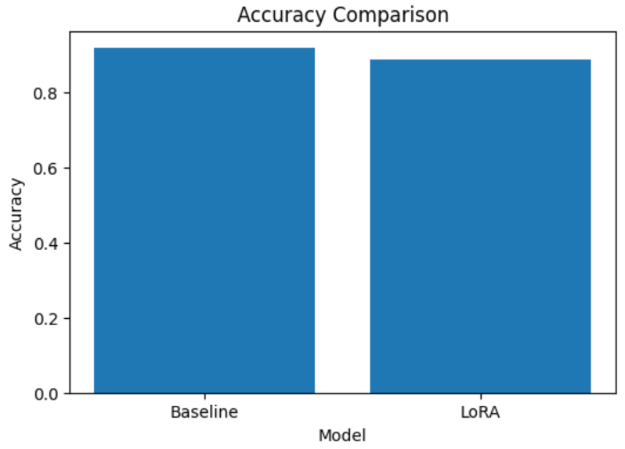
- F1 Score Comparison Graph
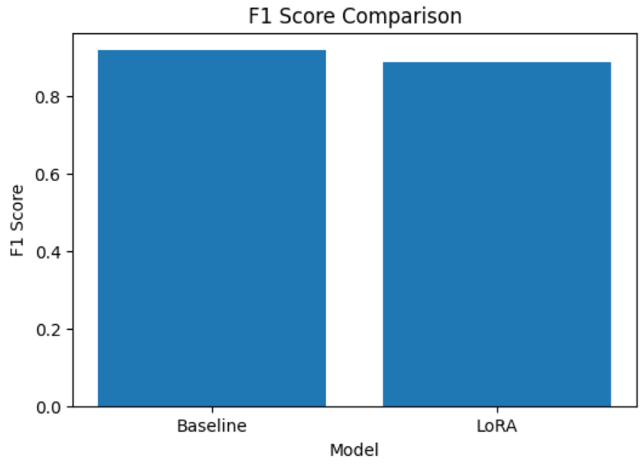
- Training Time Comparison Graph

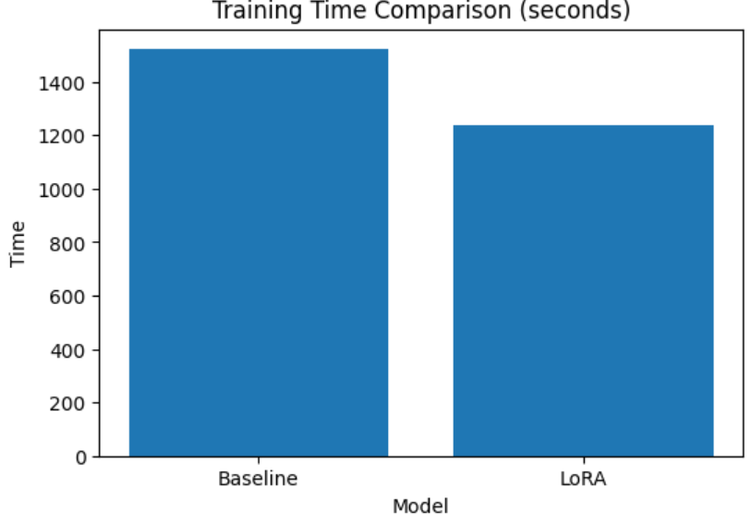
9. Code Repository
The complete implementation of this project is available on GitHub.
Github Repository Link

